1. **What is Software? What is Software engineering?**

* Software:

Software is a set of instructions, data or programs used to operate computers and execute specific tasks.

Software comprises the entire set of programs, procedures, and routines associated with the operation of a computer system.

Set of data that tell computer how to perform any program or task.

* Software Engineering:

Software Engineering is the process of

Designing,

Developing,

Testing,

And maintaining software.

Objectives of Software Engineering: Maintainability, Efficiency, Testability, Portability, Correctness.

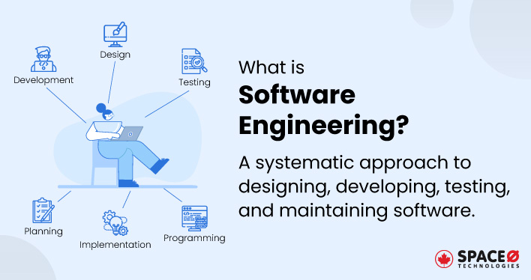

* Software engineers apply engineering principles and knowledge of programming languages to build software solutions for end users.
* The outcome of software engineering is an efficient and reliable software product.
* Software when made for a specific requirement is called software product.

1. **Explain types of software.**

The main categories of software are Application and System software.

1. Application Software:

An application software is software that fulfills a specific need or performs tasks.

1. System Software:

System software is designed to run a computer’s hardware and provides a platform for applications to run on top of.

Other subtypes of Software:

Driver Software:

A driver is a software component that lets the operating system and a device communicate.

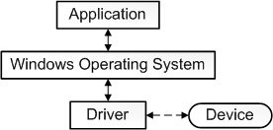

Middleware Software:

Middleware is software that lies between an operating system and the applications running on it.

Programming software:

Programming software is a software which helps the programmer in developing other software.

Compilers, assemblers, debuggers, interpreters. Etc. are examples of programming software.

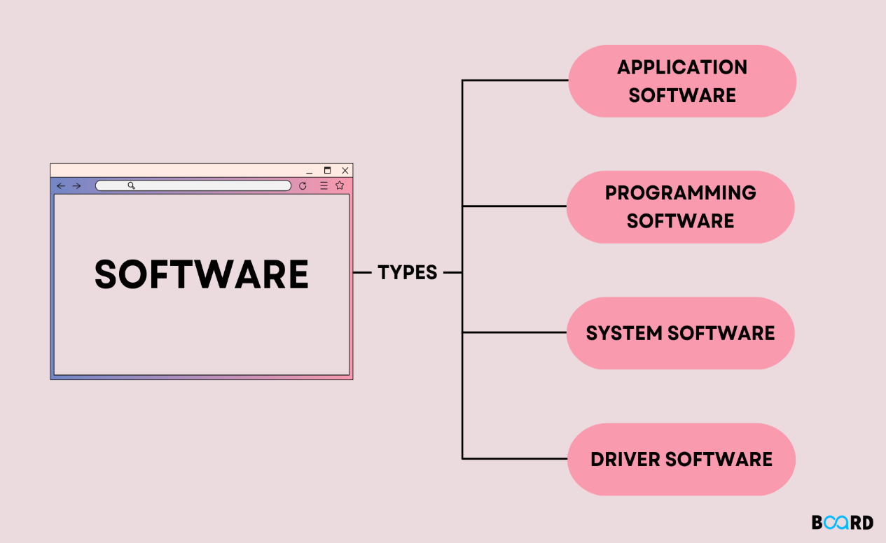

1. **What is SDLC? Explain each phase of SDLC.**

SDLC: **SOFTWARE DEVLOPMENT LIFE CYCLE**

The SDLC refers to a methodology with clearly defined process for creating high-quality software.

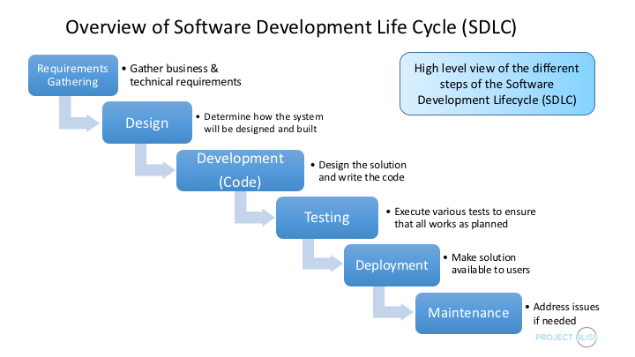

The SDLC is the **cost effective** and **time-efficient** process that development teams use to design and build **high-quality software**.

In detail, the SDLC methodology focuses on the following phases of software development

1. **Requirement Gathering:**

Requirement gathering is the act of generating list of requirements to define what a project is about and it goal.

In this phase we can decide what is actual need or requirement of our customer what they actually need from us.

1. **Analysis:**

In this phase developer analyze the customer requirements and define a useful solution for as per their need.

This is also including a feasibility study, which defines all fortes and weak points of the project to assess the overall project viability.

1. **Designing:**

In this phase developer need to made a protype structure of its project.

The design phase of the software development life cycle is a critical step in developing the conceptual blueprint of the software project.

This phase involves transforming the software requirements gathered during the requirement s analysis phase into a structured design document.

1. **Implementation:**

This is the phase in which software developer implement the actual product made by planning, analysis and designing.

In this phase system performance is compared to performance objectives established during the planning phase.

1. **Testing:**

Once the developers build the software, then it is deployed in the testing environment.

The testing phase tests the functionality of the entire system.

Testing is done to ensure that the entire application works according to the customer requirements.

1. **Maintenance:**

The maintenance phase in the software development process is where the software is monitored to ensure it continues to function as it was designed to, and repairs or upgrades are performed as needed.

After the software is released into production, updates or upgrades will need to be made**.**

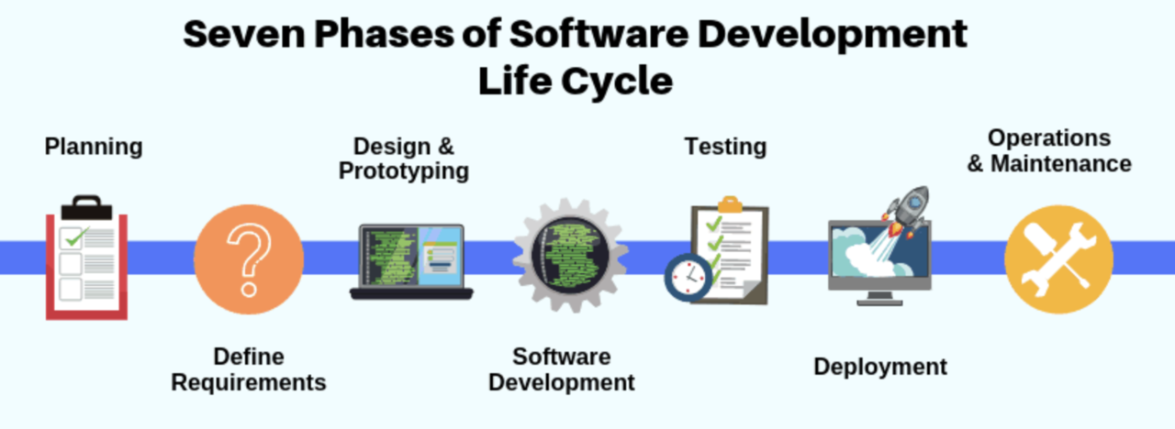

1. **What is DFD? Create a DFD diagram on Flipkart.**

DFD: Data Flow Diagram

The flow of data of a system or a process is represented by DFD.

It also gives insight into the inputs and outputs of each entity and the process itself.

DFD does not have control flow and no loops or decision rules are present.

DFD are very useful in understanding a system and can be effectively used during analysis.

It provides an overview of

What data is system processes.

What transformation are performed.

What data are stored.

What results are produced etc.

The process are shown by named circles and data flows are represented by named arrows entering or leaving the bubbles.

A rectangle represents a source or sink and it is a net originator or consumer of data.

Components of DFD:

Process

Data Flow

Data Store

External Entity

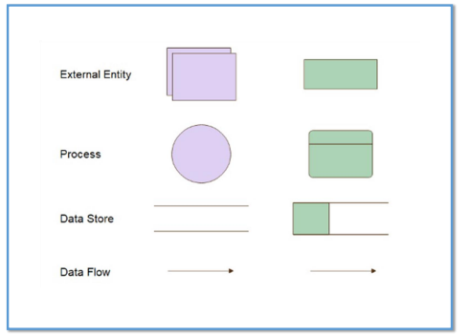

Here is DFD diagrams related to Flipkart.

By following diagrams, a software developer can represent their design as graphical and show them entire process throughout the diagram.

First of all, we will see the Level 0 diagram in which briefly overview of entire system will present.

Also, we can see different stages in detais by DFD diagram for each stage.

In last we will see Level 1 diagram in which we see all the stages together in detail.

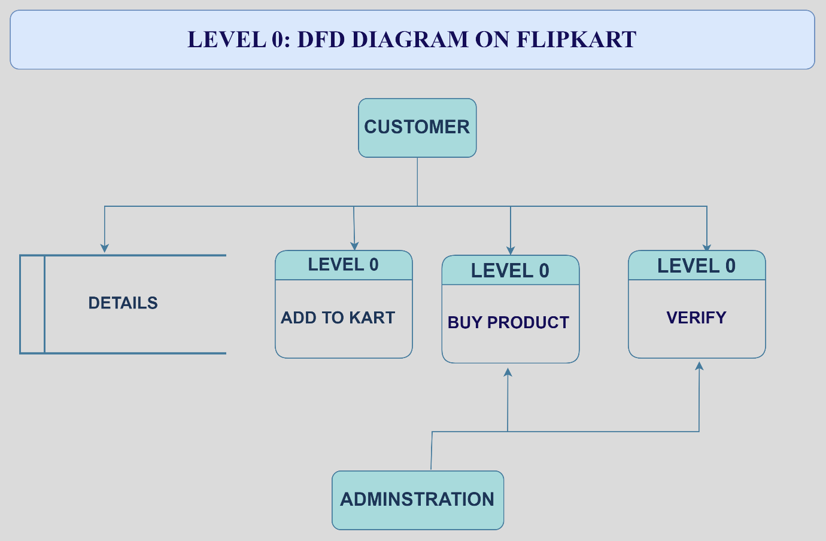

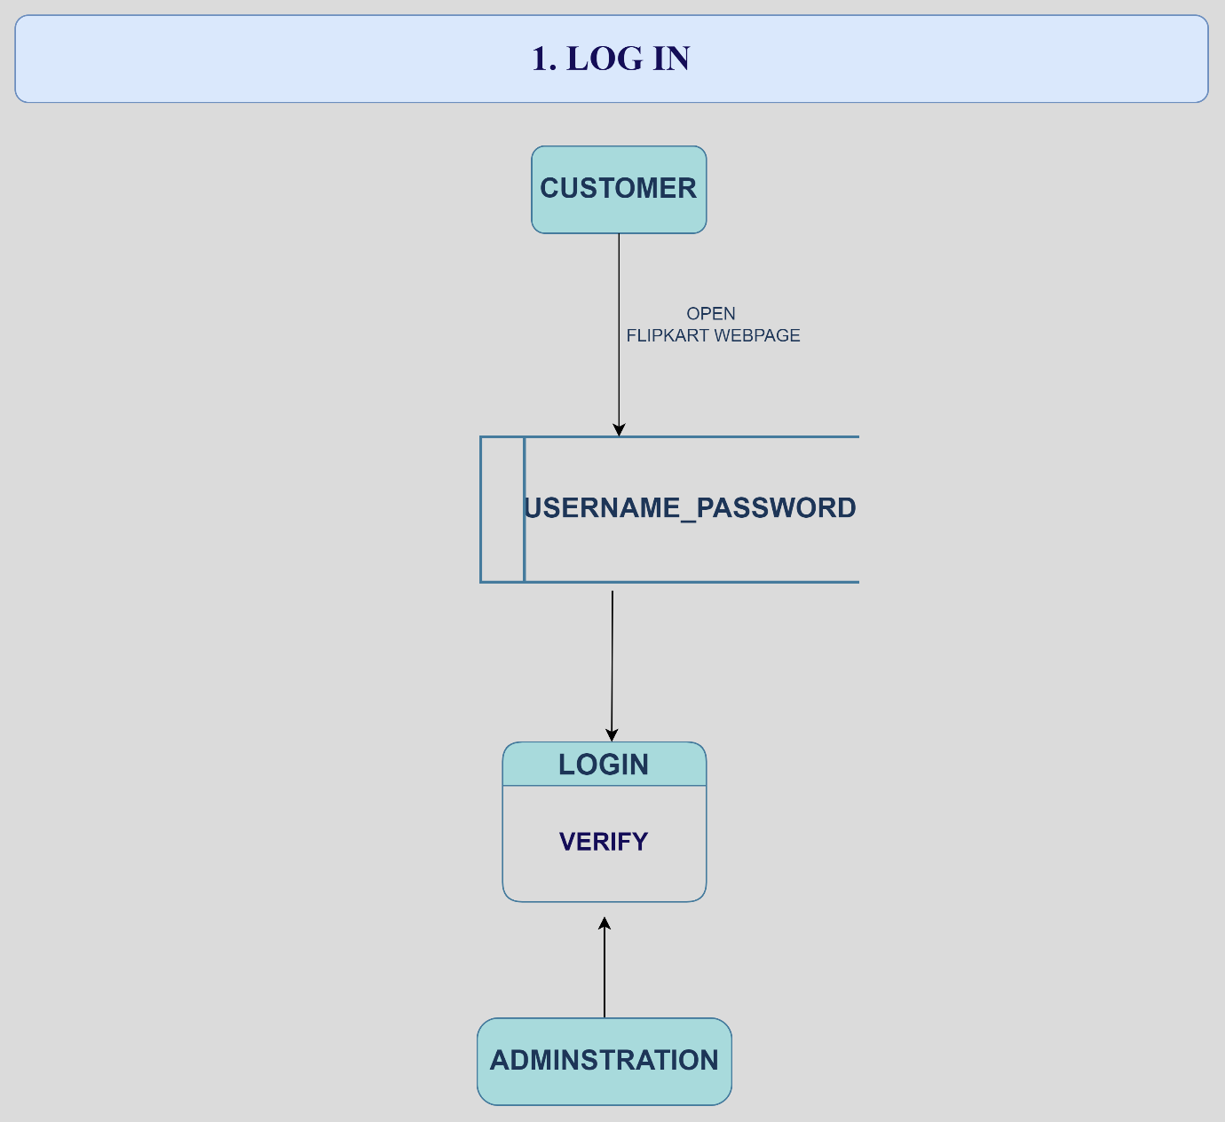

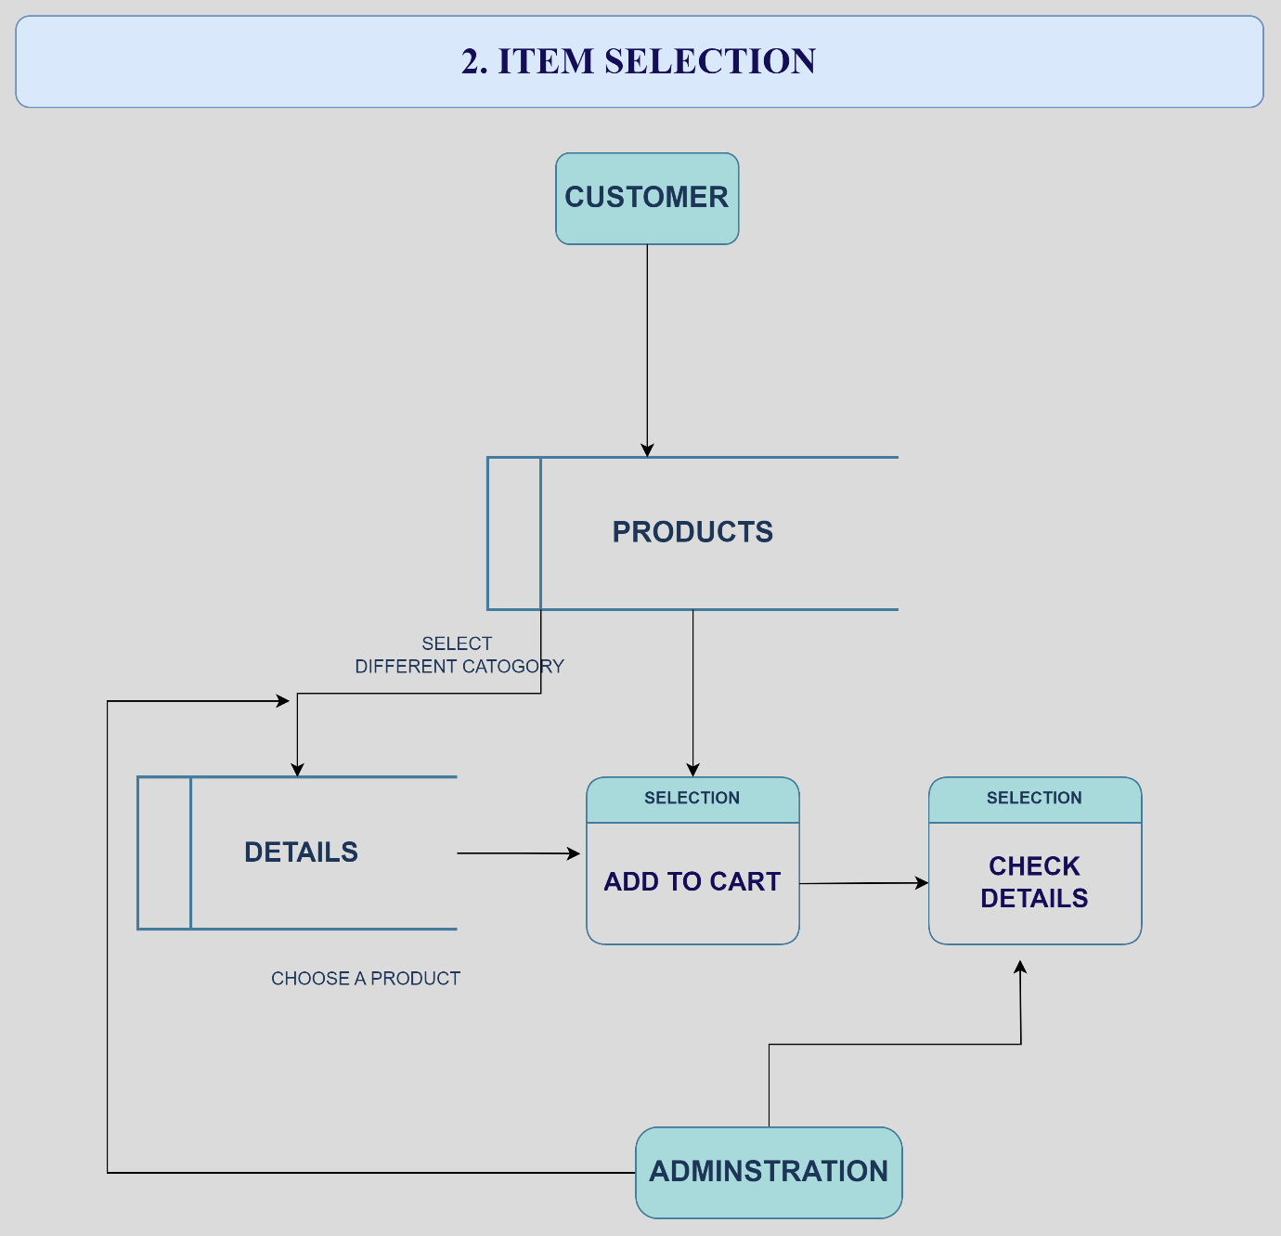

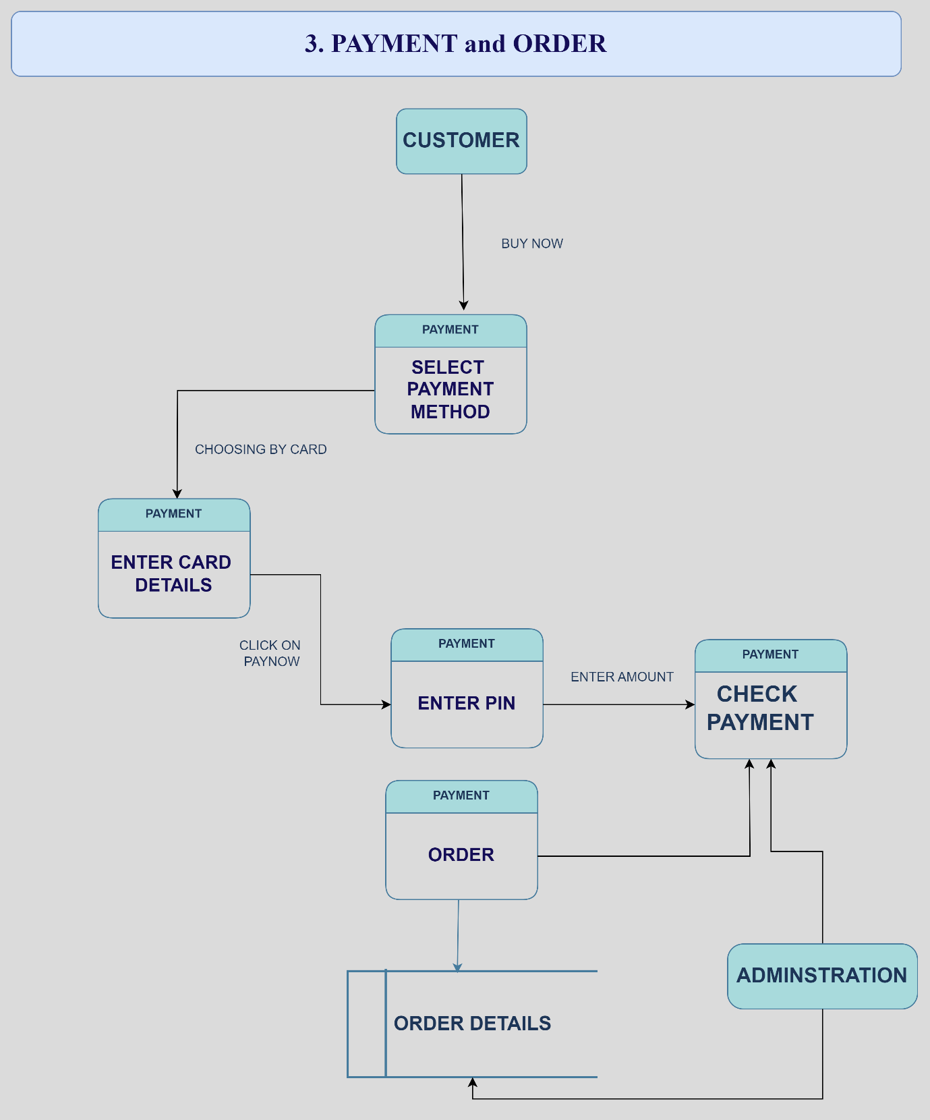

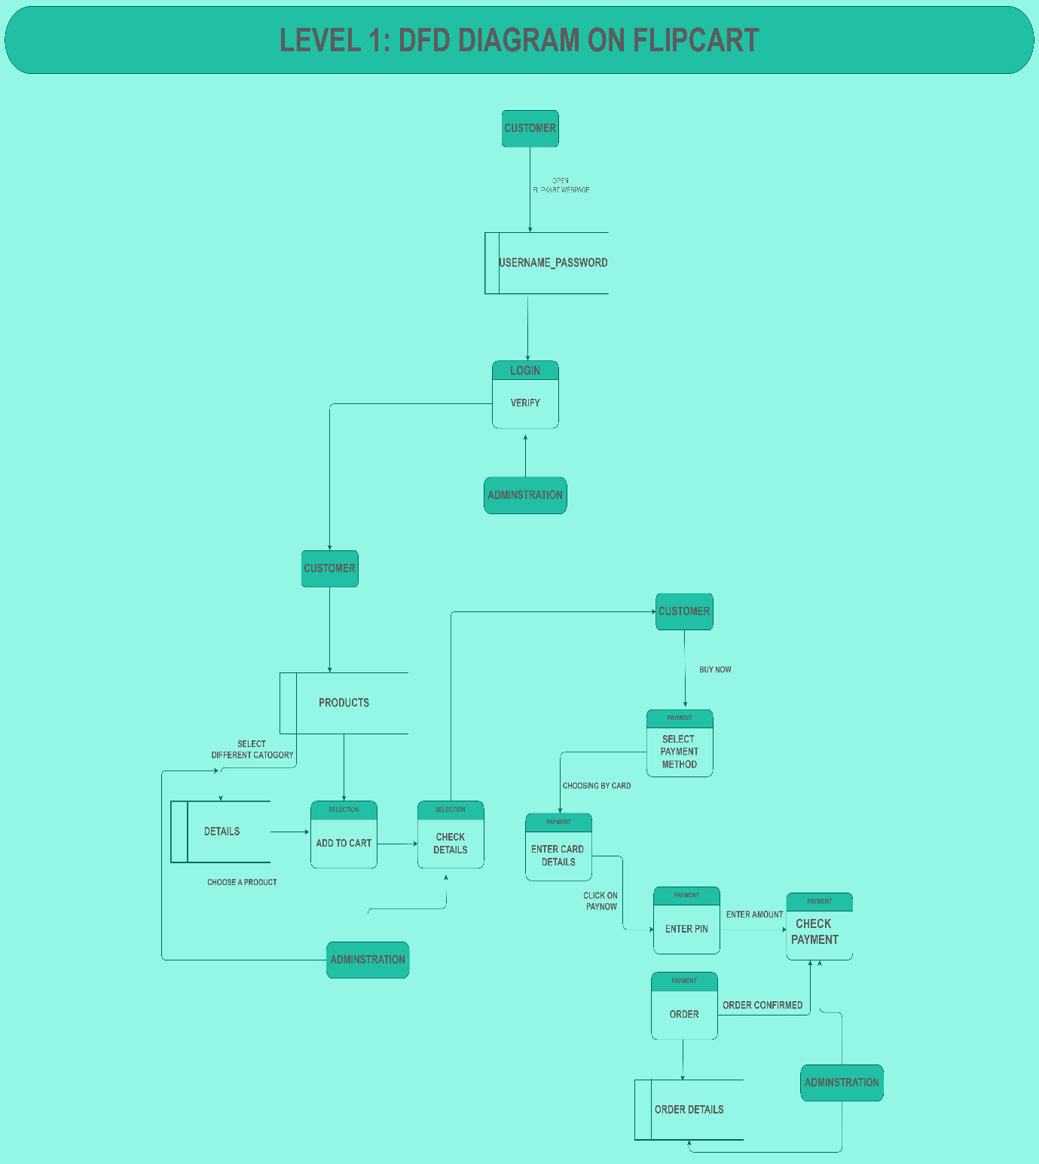

1. **What is Flow chart? Create a flowchart to make addition of two numbers.**

A flowchart is a diagram that depicts a process, system or computer algorithm.

Simply it is a graphical representation of an algorithm.

A flowchart is a type of diagram that represent a work flow or process.

They often use symbols, shapes, and arrows to illustrate how one step leads to another.

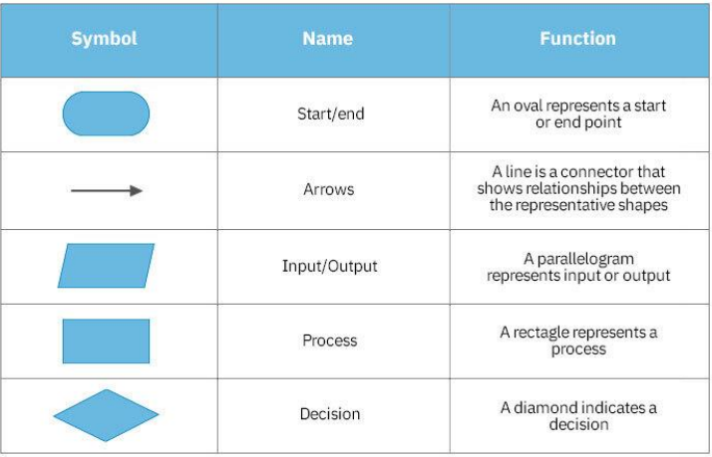

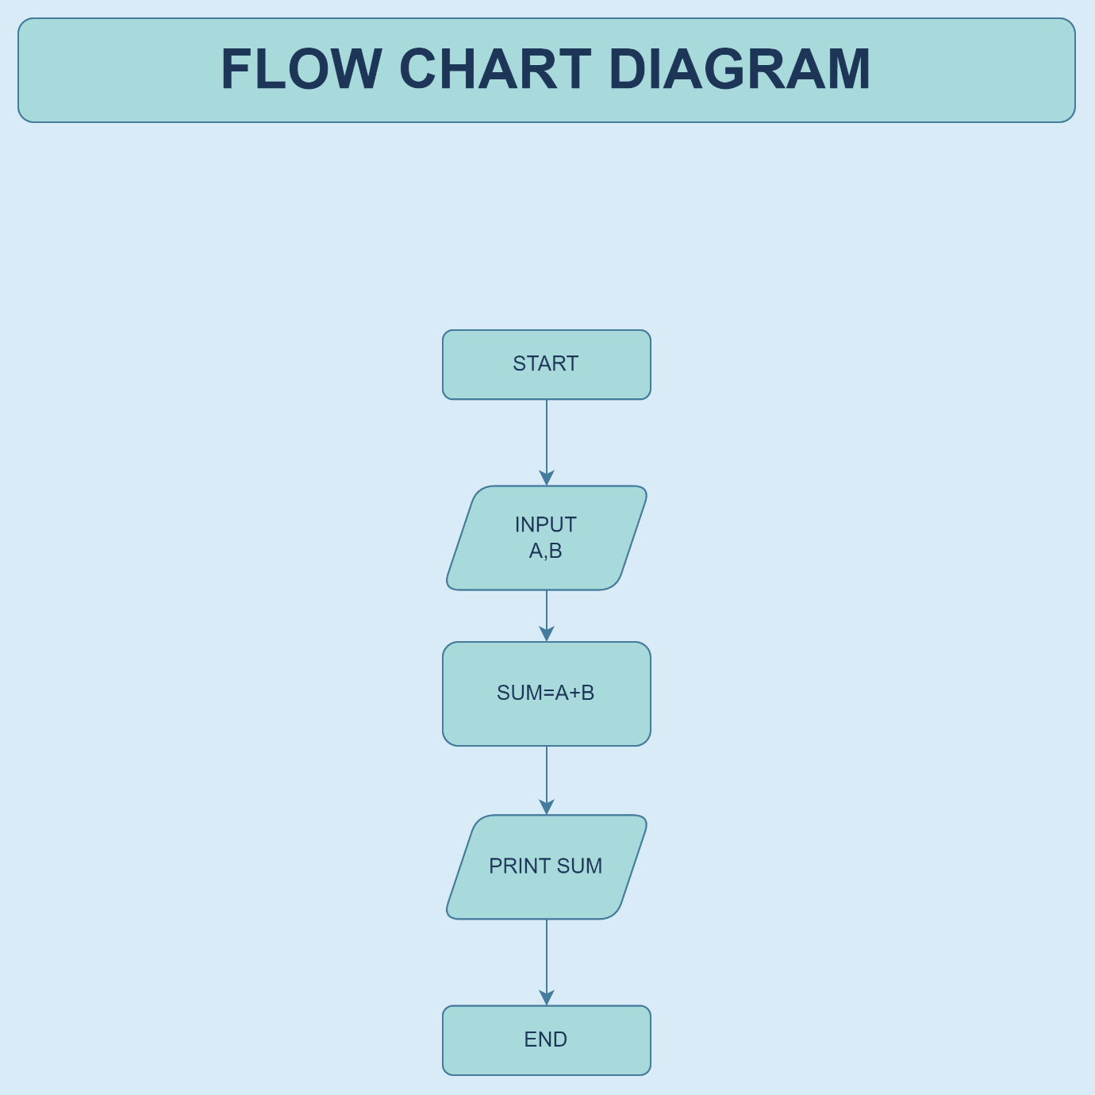

1. **What is Use case Diagram? Create a use**

**case on bill payment.**

**Definition:**

In use case diagram a graphical depiction of a user’s possible interactions with a system is described**.**

The use cases are represented by either circles or

ellipses.

 The actors are often shown as stick figures.

A use case diagram shows various use cases and different types of users the system has and will often be accompanied by other types of diagrams as well.

There are various components of the basic model:

1. Actor

2. Use Case

3. Associations

